Problem Statement: XYZ Company requires an Ecommerce Single Page application ,The Initial requirement for the company is first page is the SearchForm this page the person can search the product, another page should show all the available products.

- Use the following json file to store the data filename should be db.json(use the same data):
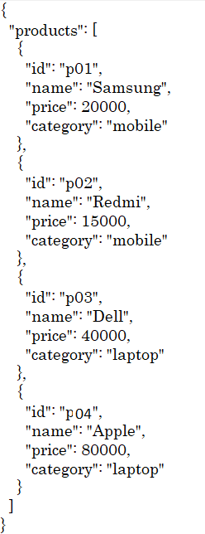

- Design the following using Angular using router concept such that when the first page is loaded, it will redirect to Searchform the page should be like this.

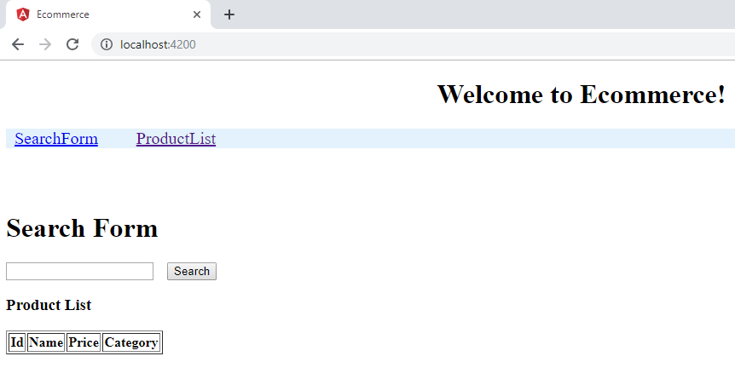

- When person click on Search Form page should be visible, person can search the product by name or by category. The screen shot should be like this.

By Name of the product (user can enter any case product name but it should be visible)

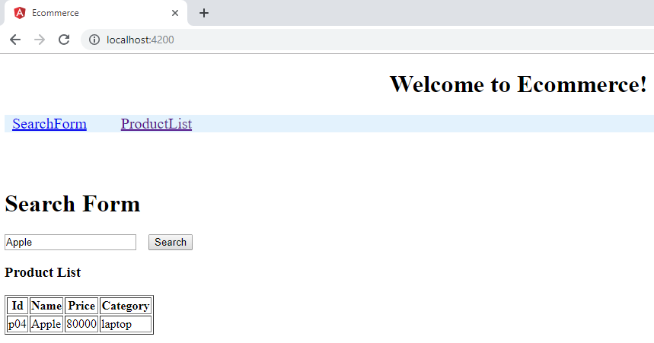

By Category of the product (user can enter any case category name but it should be visible)
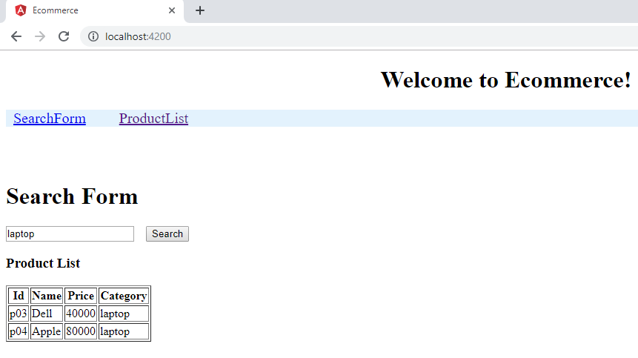

- When person click product List it should display all the available products details as follows.

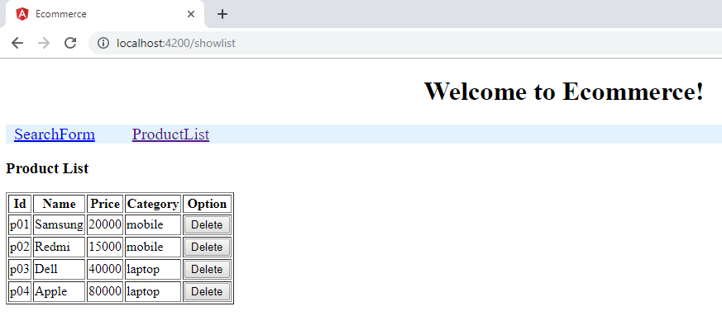

- When person click on the Delete button, that row will be deleted, example when click on the Apple delete button entire row get deleted, then page should show as follows.

